***Assembly and calibration instructions***

1. *Acquire the components*

Order the printed circuit board and order the components described on the bill of materials: <https://github.com/XaviCanoFerrer/Sport_Analyzer/tree/main/Bill%20of%20Materials>. The PCB can be ordered on JLCPCB: <https://jlcpcb.com/>.

1. *Manufacture the Sport Analyzer case*

The case has been designed in a way that the components can be laser cut or 3D printed, which are the two most common manufacturing processes available for makers (Figure 1). The files can be found on <https://github.com/XaviCanoFerrer/Sport_Analyzer/tree/main/Manufacturing%20files>.

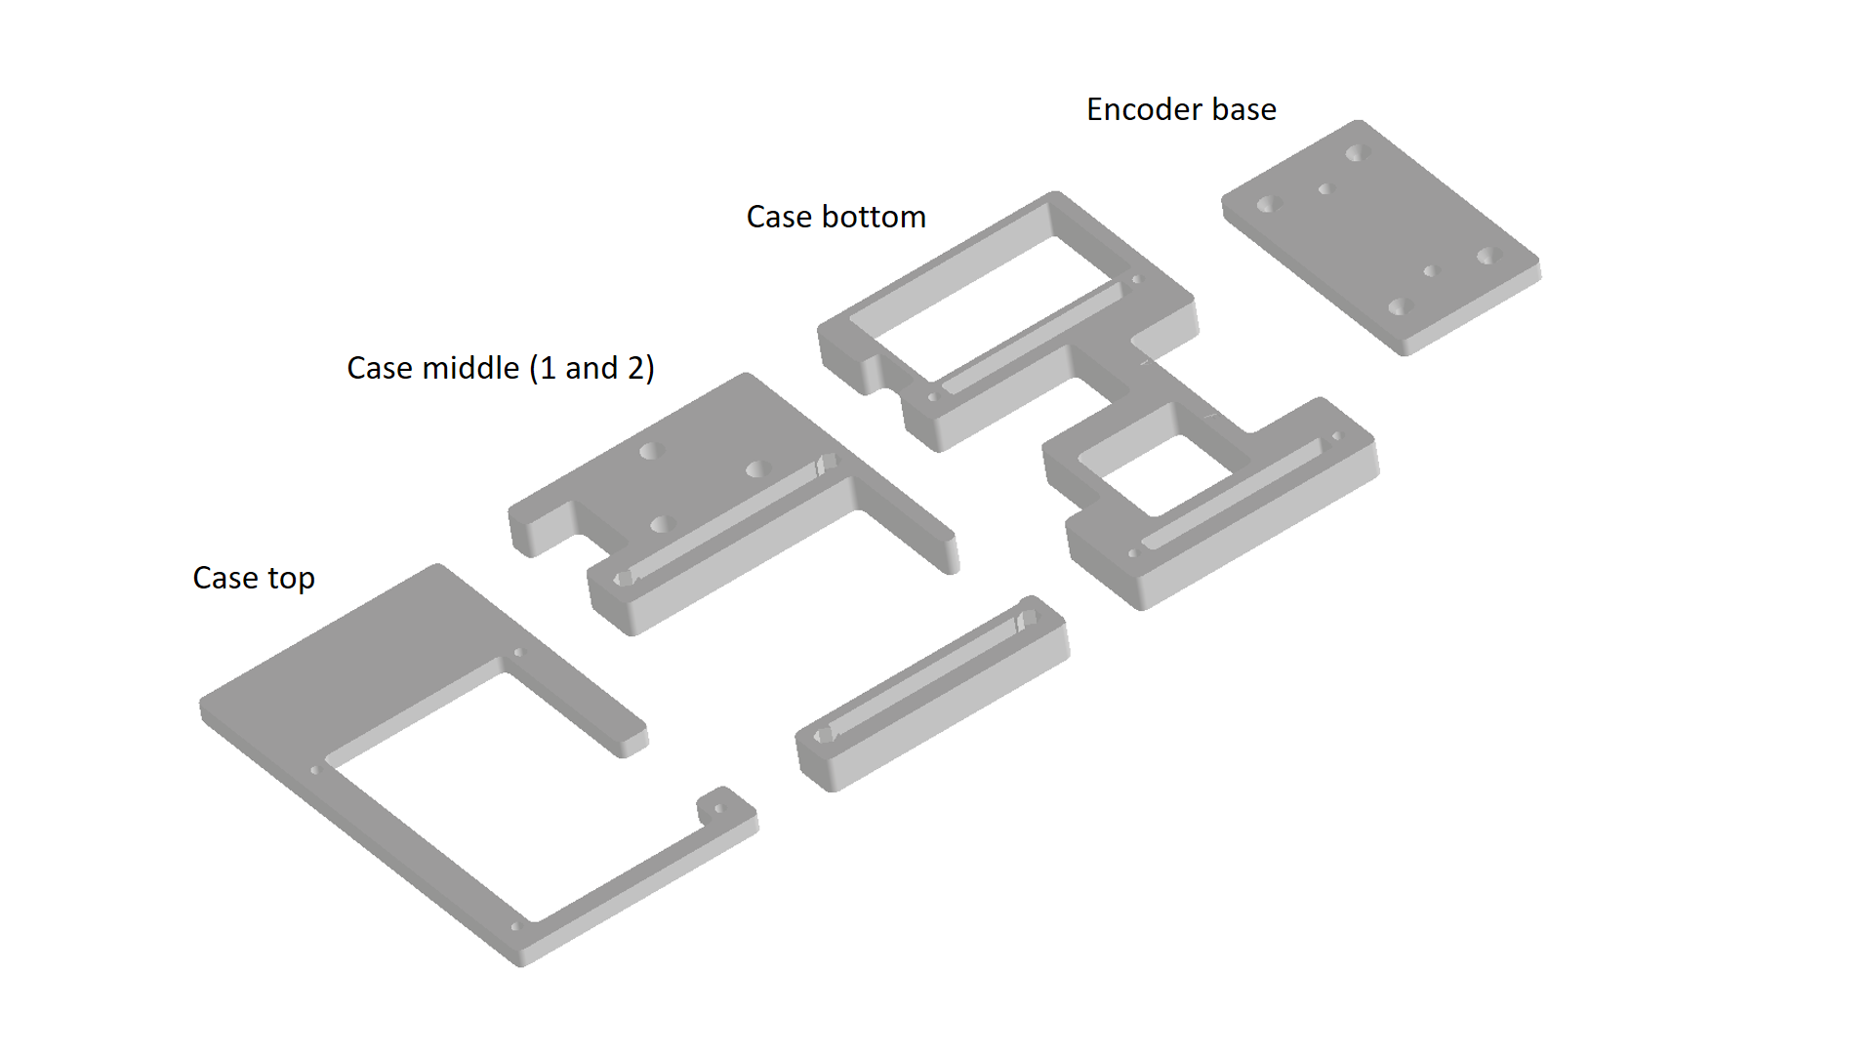

Figure 1: Components of the case.

1. *Solder the components on the Board*

In order to hold the surface mount components (SMD) it is highly recommended to use tweezers to hold the small capacitors and resistors. All components can be soldered by adding solder on one of the pads and then fuse the solder by touching it with the soldering iron while holding the component in place helping yourself with the tweezers and they are labelled on the solder mask of the PCB (Figure 2). The pin headers that hold the screen (TFT_2.8”_RIGHT and TFT_2.8”_LEFT) must be soldered on the opposite layer (Top layer).

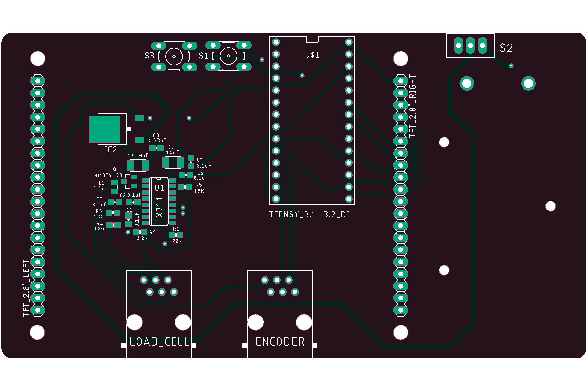

Figure 2: Bottom layer of the PCB.

1. *Case assembly*

The three components of the case (top, middle and bottom) are assembled using four hexagonal spacers and eight M3 screws that hold them together (Figure 3).

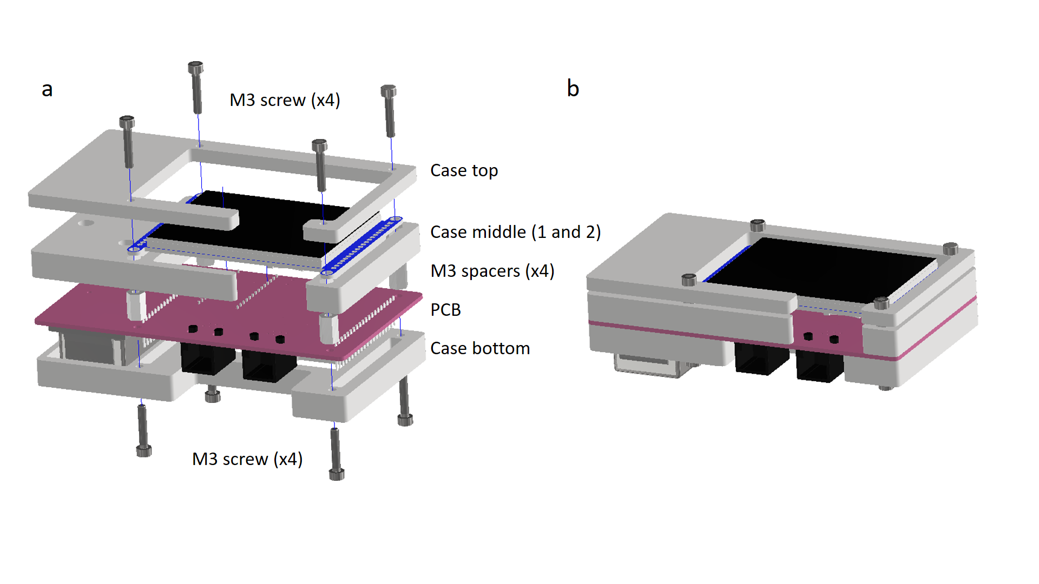

Figure 3: Exploded and assembled views of the case with the board.

1. *RJ12 cable connections*

The load cell and the encoder are connected with the Sport Analyzer using RJ12 (6 wire) connections. In Figure 4 is described which wires must be soldered with which ones to have a successful connection with the sensor leads.

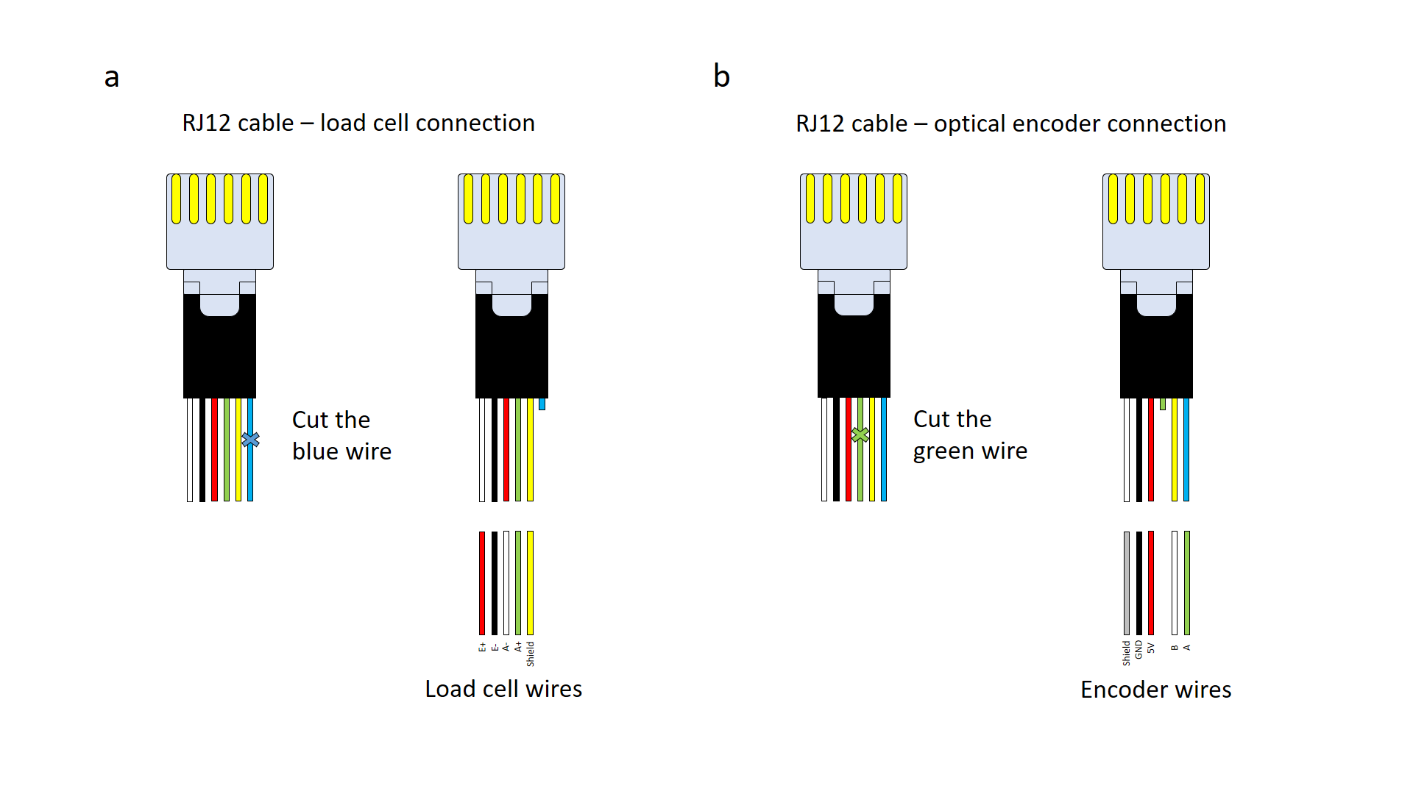

Figure 4: RJ12 cable connections for the load cell and the encoder.

1. *Load cell building*

The only manufacturing process on the load cell side is the soldering of the RJ12 cable with the load cell cable as described on (Figure 4a). The RJ12 cable must be strip leaving approximately 30 cm of cable from the connector to the cut. Then solder can be applied on each of the wires of both sides (Figure 5a). A big heat shrink with bigger diameter than the cable and six smaller ones can be applied on the wires (Figure 5b). Then solder each of the wires one by one and apply heat on the small heat shrinks (Figure 5c). Now surround the five small wires with the big heat shrink and apply heat getting a continuous cable again (Figure 5d-e). The final step is to screw the M12 eye bolts on both sides of the load cell (Figure 5f).

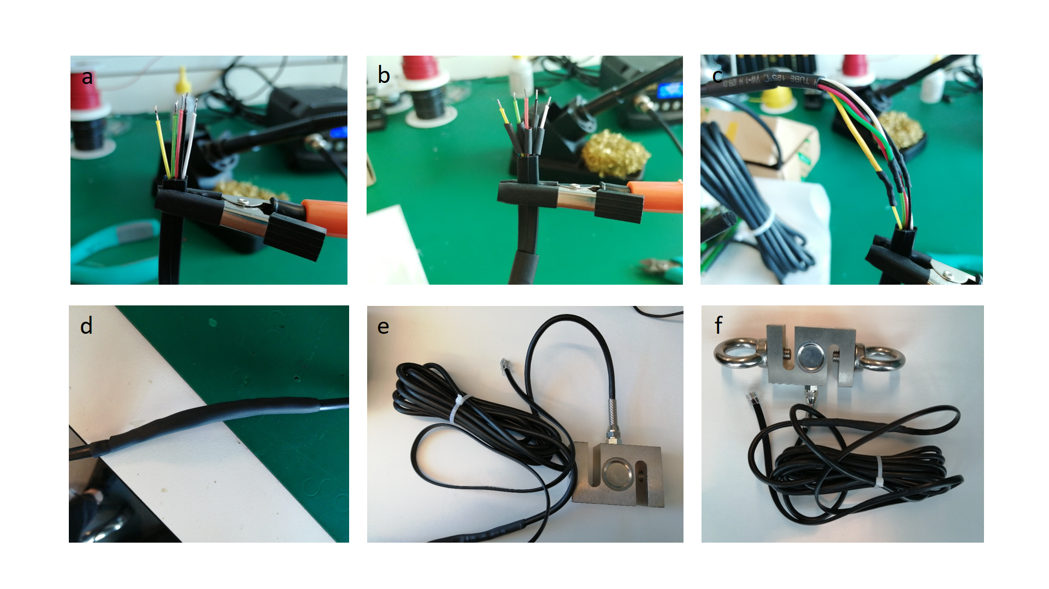

Figure 5: Load cell soldering and assembly process.

1. *Encoder building*

The encoder soldering process is very similar to the one described with the load cell. How to connect the sensor cables with the RJ12 connector can be found in Figure 4b. The RJ12 cable must be strip leaving approximately 30 cm of cable from the connector to the cut. Then solder can be applied on each of the wires of both sides (Figure 6a). A big heat shrink with bigger diameter than the cable and six smaller ones can be applied on the wires. Then solder each of the wires one by one and apply heat on the small heat shrinks (Figure 6b). Now surround the five small wires with the big heat shrink and apply heat getting a continuous cable again (Figure 6c). The next steps describe how to assemble the incremental encoder with the draw-wire mechanism which converts the rotational movement into translational movement. Place the draw-wire mechanism facing the Allen key screws up. Both M3 screws have to be removed (Figure 6d). Then the top part has to be carefully lifted keeping the rotary part in the original position (Figure 6e), this is important because it is keeping the spring in place and if lifted the spring will come off being really difficult to put back. Then use 3 M3 screws to attach the incremental encoder with the top part (Figure 6f). Attach the top part with the bottom part placing the encoder shaft inside the rotary part and attaching bottom and top with the two M3 screws previously removed (Figure 6g). The linear encoder assembly is completed (Figure 6h). The same process can be found on the following link provided by the manufacturing company: <https://www.youtube.com/playlist?list=PLo6Bmj-F0yyxRFb8ynPXJDACgFAKuwAJT>.

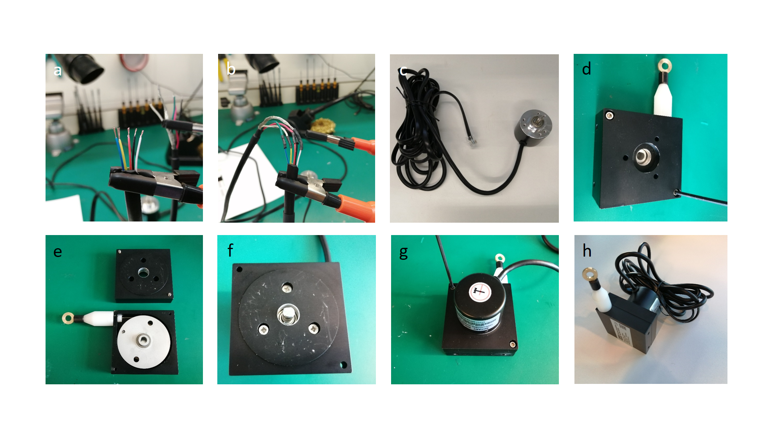

Figure 6: Linear encoder soldering and assembly process.

1. *Encoder base building*

Make chamfers on the 3 mm holes of the encoder base. Attach the magnets with the encoder base using four M3 screws (Figure a-b). Then attach the encoder base with two M4 screws (10 mm length) (Figure c-d).

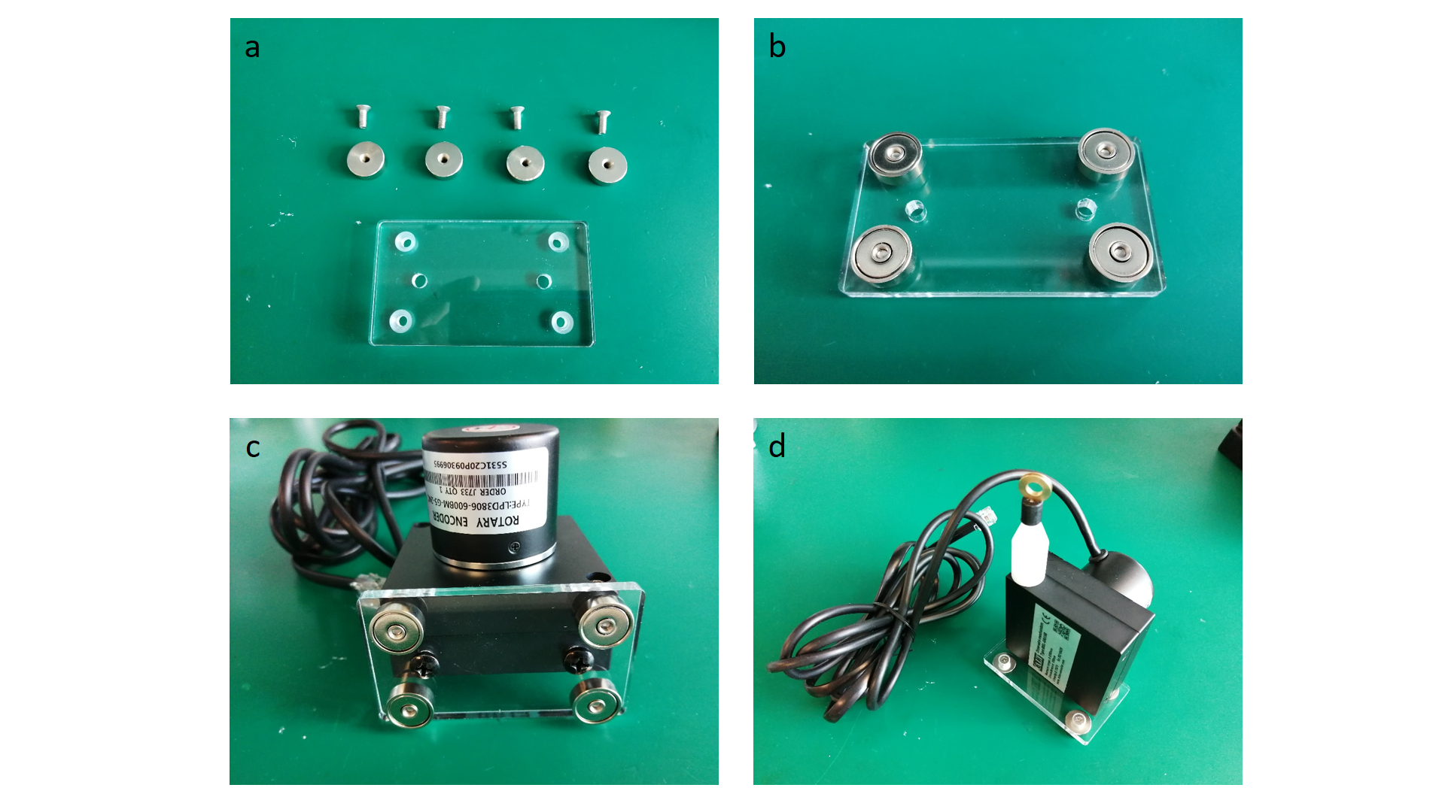

Figure 7: Base building and assembly.

1. *Load cell calibration*

Open the excel file: *Load cell calibration.xlsx* that can be found on: <https://github.com/XaviCanoFerrer/Sport_Analyzer/tree/main/Calibration/Load%20cell%20calibration>. Upload the calibration program to the Sport Analyzer <https://github.com/XaviCanoFerrer/Sport_Analyzer/tree/main/Calibration/Calibration>. For this calibration you are going to need eight different weights to get a five-point calibration equation (Remember that the first value is the one that corresponds to zero). Weight the load cell using a scale and add the weight on the excel file on the “Load cell mass” field. Attach the load cell on one side using a rigid rope or strap. Then hang each of the weights from the load cell and introduce the weight and the sensor value you can see on the screen on the “Mass suspended (kg)” column. Repeat this step for each of the weights replacing the ones you will find on the file. Then you will see the calibration equation displayed on the excel scatter plot. Download and open the Firmware.ino <https://github.com/XaviCanoFerrer/Sport_Analyzer/tree/main/Firmware/Sport_Analayzer_1.0>

and replace the load cell equation (F = 0.0011*load_cell_reading - 1.248;) by your equation and save the file.

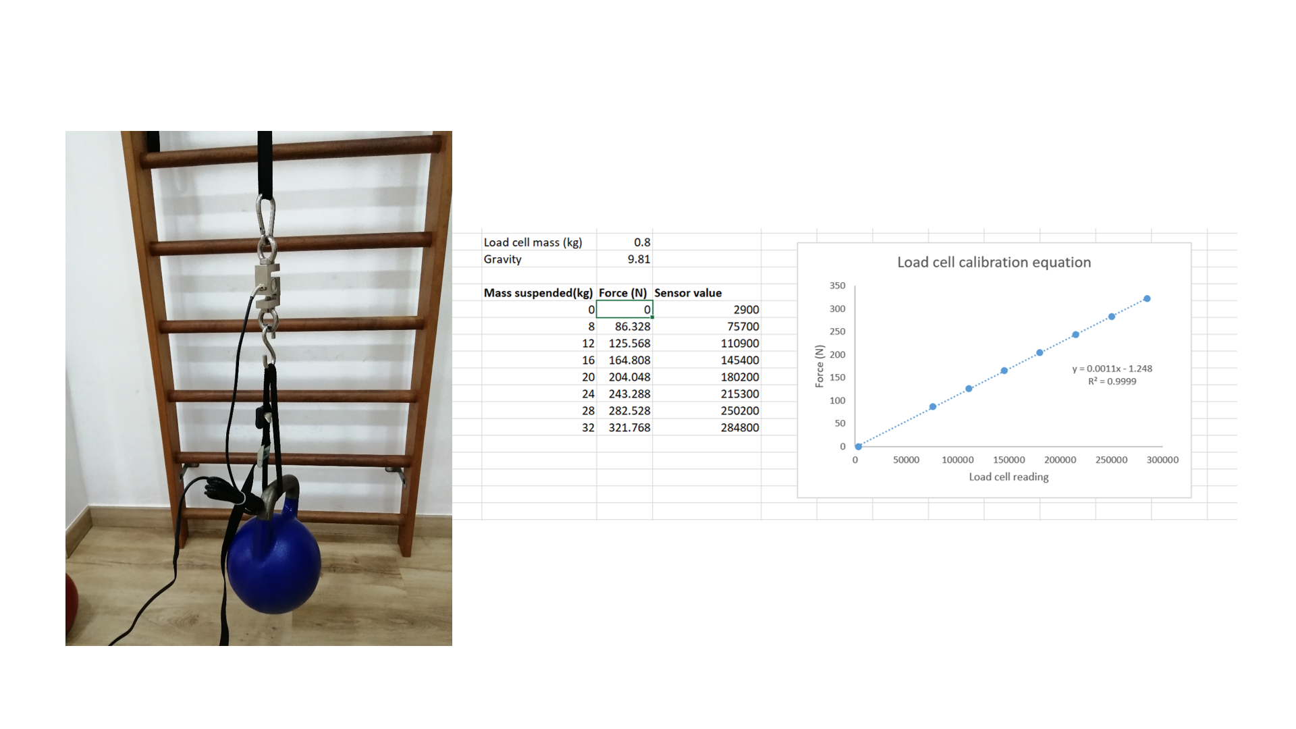

Figure 8: Load cell calibration excel file.

1. *Encoder calibration*

Open the excel file: *Encoder calibration.xlsx* that can be found on: <https://github.com/XaviCanoFerrer/Sport_Analyzer/tree/main/Calibration/Encoder%20calibration>. Upload the calibration program to the Sport Analyzer <https://github.com/XaviCanoFerrer/Sport_Analyzer/tree/main/Calibration/Calibration>. Hold a 50 cm ruler on a flat surface with tape. Perform the proposed measurements and add them one by one to the excel sheet (Figure 9). The excel sheet will calculate the average pulses per millimetre and it inverse millimetre per pulse. In case the encoder resolution is different from the encoder proposed replace the encoder resolution constant (mmpp) on the Firmware.ino program as done before with the load cell equation.

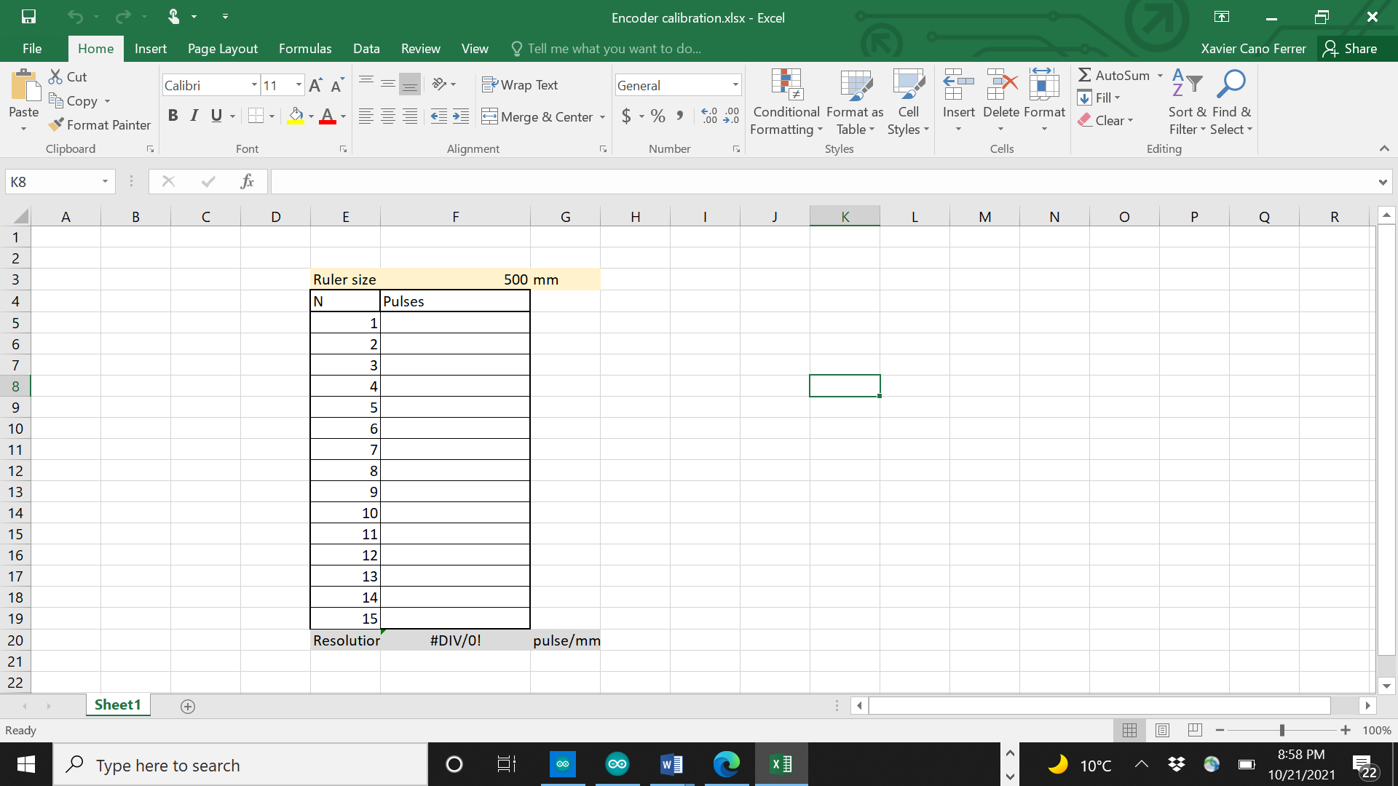

Figure 9: Encoder calibration excel file.